M2S150 ADV DEV KIT EEPROM Programming Procedure.
- Download and Install FT_PROG from FTDI website.
  - File to download: http://www.ftdichip.com/Support/Utilities/FT_Prog_v2.8.2.0.zip
  - Help files: http://www.ftdichip.com/Support/Utilities.htm (Search for FT_PROG).

- Connect USB cable (mini USB to Type A USB cable) to J33 and other end connect it to USB port of test PC.

- Run FT_PROG. Window will open as shown below.
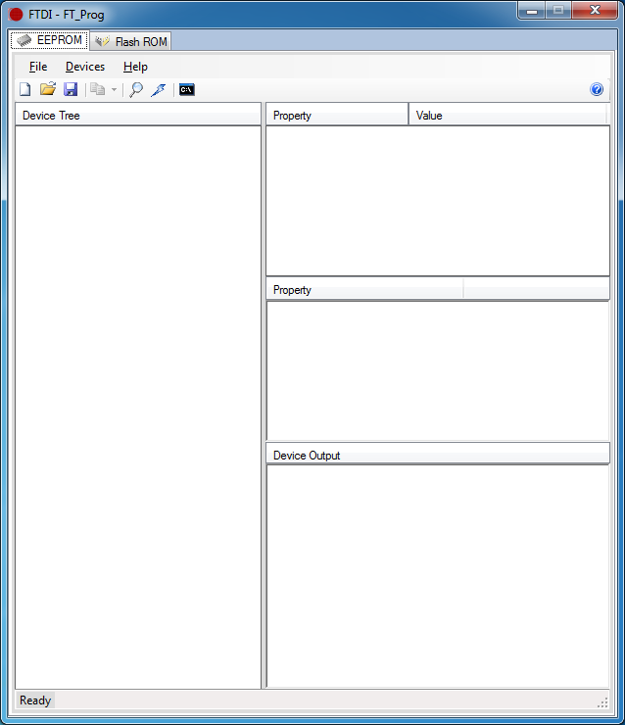

- Hit F5 key to run “Scan and Parse” command. Below window will appear:
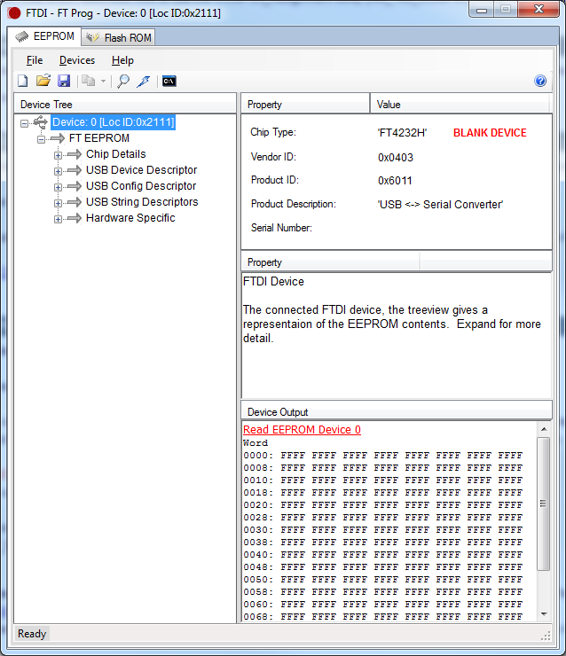
- Right click on “Device: 0” on the left window.
- Select “Apply Template” then “From File”.
- Select “EmbeddedFp5.xml”. This file will be provided by Microsemi.
- After selecting “EmbeddedFp5.xml” below window will open.
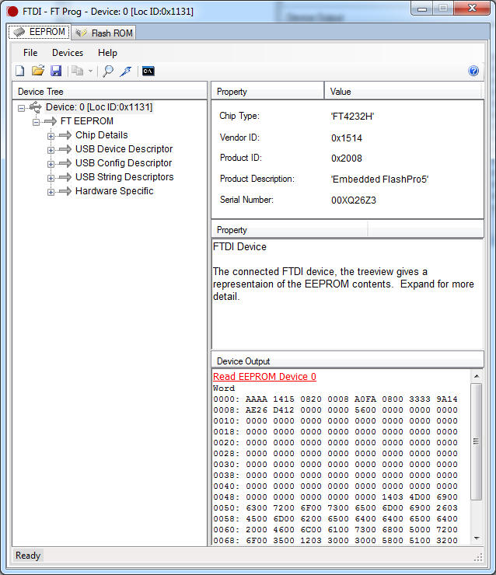

- Click on “USB String Descriptors” option and fill the prefix value.
Note: Prefix value will be provided by Microsemi. By default prefix value set to 00 in the template.
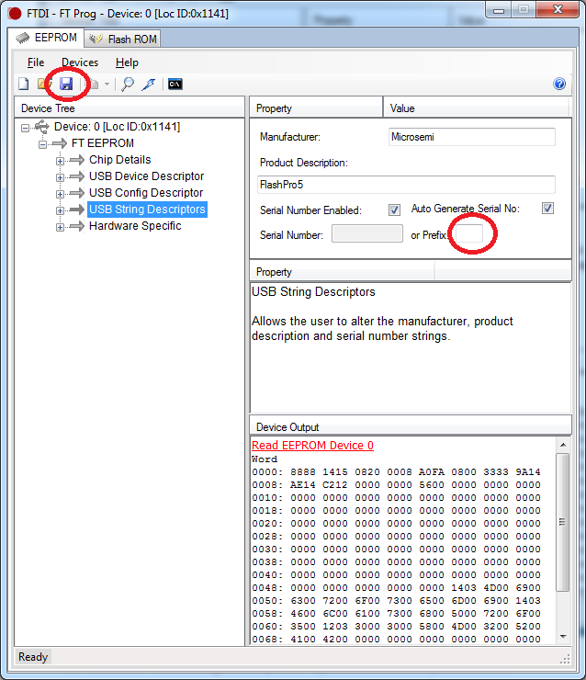

- After setting the prefix value save the template on test PC by pressing save button on utility (e.g.:- EmbeddedFp5.xml _Prefix_XX).
- Again right click on “Device: 0” on the left window.
- Select “Apply Template” then “From File”.
- Browse on test PC and Select “EmbeddedFp5.xml _Prefix_XX”. This file is with updated Prefix value.
- Right click again on “Device: 0”
- Select “Program Device”

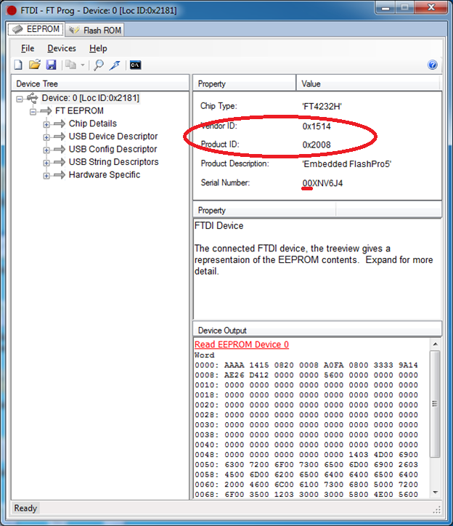
Note:-
- Product description should be Embedded FlashPro5.
- Vendor ID should be 0x1514
- Product ID should be 0x2008
- Serial Number first two digits/characters should be same as prefix provided by Microsemi.

